**Experiment No: 5**

**SINGLE SOURCE SHORTEST PATH**

**Aim:** To implement single source shortest path using greedy approach.

**Theory:**

Greedy algorithms build a solution part by part, choosing the next part in such a way, that it gives an immediate benefit. This approach never reconsiders the choices taken previously. This approach is mainly used to solve optimization problems.

Greedy method is easy to implement and quite efficient in most of the cases. Hence, we can say that Greedy algorithm is an algorithmic paradigm based on heuristic that follows local optimal choice

**Single source shortest path:**

It is a greedy algorithm that solves the single-source shortest path problem for a directed graph G = (V, E) with nonnegative edge weights, i.e., w (u, v) ≥ 0 for each edge (u, v) ∈ E.

Dijkstra's Algorithm maintains a set S of vertices whose final shortest - path weights from the source s have already been determined. That's for all vertices v ∈ S; we have d [v] = δ (s, v). The algorithm repeatedly selects the vertex u ∈ V - S with the minimum shortest - path estimate, insert u into S and relaxes all edges leaving u.

Because it always chooses the "lightest" or "closest" vertex in V - S to insert into set S, it is called as the greedy strategy.

**Algorithm-**

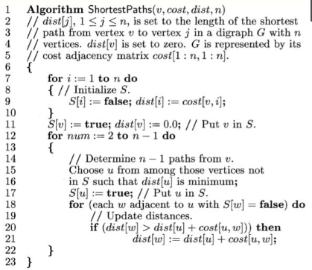

**Program and Output:**

**Conclusion:**

Single source shortest path using greedy approach was studied and implemented successfully.